CHAPTER NO 10

APPLICATION SOFTWARE

DEFINATION:
“Application software consists of programs designed to perform specific tasks for users”.
Application software can be used as a productivity/business tool; to assist with graphics and multimedia projects; to support home, personal, and educational activities; and to facilitate communications.
Application software divided in to two main types
- Custom based software
- Package software
CUSTOM BASED SOFTWARE:
“The software which is specified by the software vendor/producer for a specific organization or institute is called custom based software”
All organization which wants use custom software must buy a license for usage and Installation it in number of computers.
Example:
NADRA used special custom based software for registration of Pakistani nationals.
GENERIC PACKAGED SOFTWARE:
Generic software package is a package that can be put to a wide variety of uses. it is design for general public uses. For example a spreadsheet package can be used for any task involving calculations or graph plotting. The most common generic software packages are:
- Word Processor
- Presentation Software
- Database
- Spreadsheet
- Communication software
- Desktop Publisher
- Graphics Package

WORD PROCESSOR
“A word processing package is used to prepare and edit text.”
Word processors are used to create all types of documents such as letters, reports and essays. Using a word processor you can type, revise and correct a document on the screen before printing it out.
The layout of the page can be changed and a wide variety of different styles of text can be used to improve the presentation of a document. Tools such as spelling checkers can help ensure that the contents of a document are accurate.
The functions of a word processor can be divided up into several different categories:
- Page Layout : The page layout functions let you decide how each page will be set out.
- Text Presentation : The appearance of text can be easily altered. Different fonts and styles can be used and the size of text can be varied. Text can be neatly lined up on the page.
- Editing of Text : Text editing functions are used to revise and change text that you have entered.
- Blocks of Text: The style and position of selected blocks of text can be changed.
- Text Analysis : The word processor can look at your document and try to highlight any errors such as spelling or grammatical mistakes that you have made.
- Templates: Template files let you save favorite document layouts that you have created so that you can use them over and over again.
- Other Features: Most modern word processors will offer lots of extra features such as tables, bullet points and fancy text effects.
- Mail Merging : A database of names and addresses can be used to personalize letters that have been created in a word processor

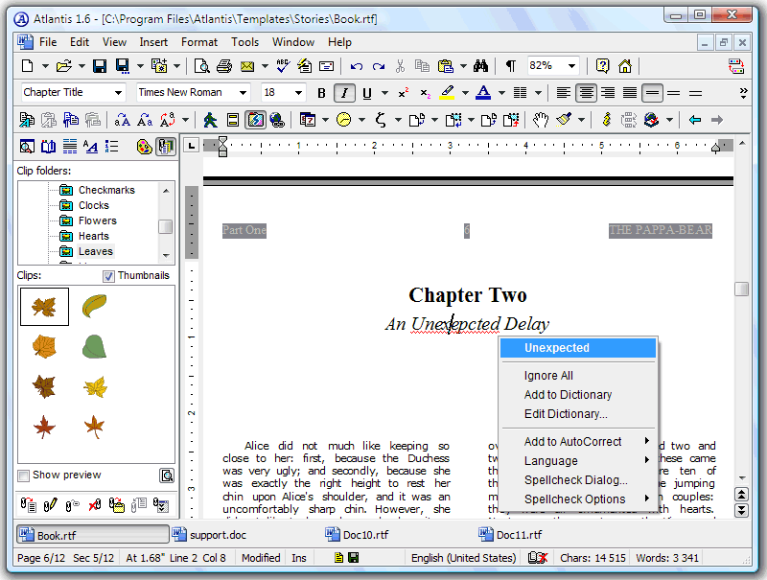

PRESENTATION SOFTWARE
“A software program for creating graphic presentations with visual aids, handouts, slides, etc. software for creating text with graphics, audio, and/or video; also called presentation graphics”
- Presentation graphics: Presentation software sometimes called "presentation graphics". It is a category of application program used to create sequences of words and pictures that tell a story or help support a speech or public presentation of information.
- Multimedia authoring tools: Presentation software can be divided into business presentation software and more general multimedia authoring tools, with some products having characteristics of both.
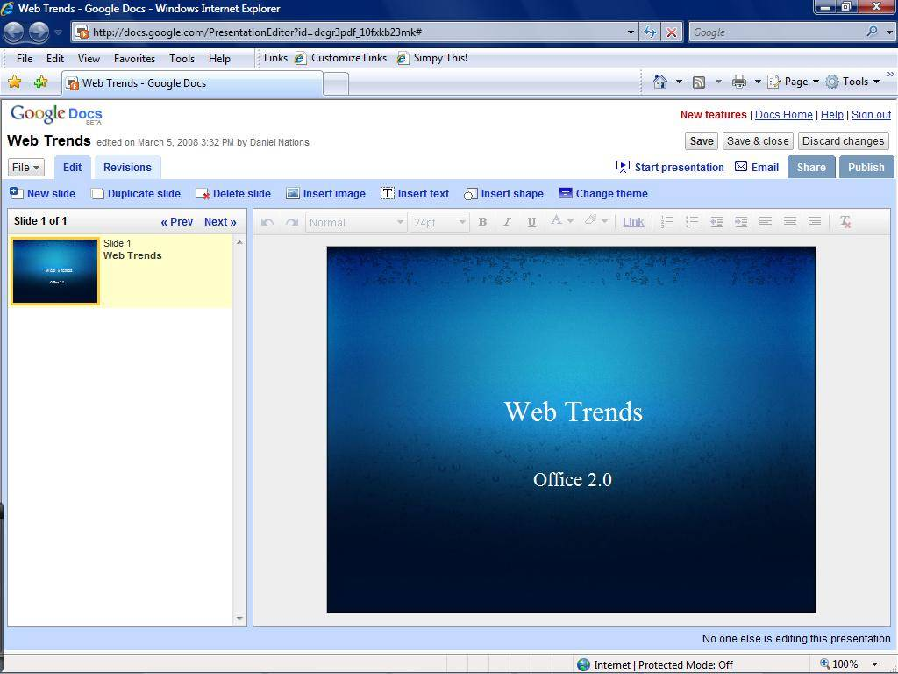
- Audio and video sequences: Multimedia authoring software enables you to create a more sophisticated presentation that includes audio and video sequences. Business presentation software usually enables you to include images and sometimes audio and video developed with other tools.

DATABASE SOFTWARE
“A database is a computerized record-keeping system. Databases are used when a large quantity of data has to be stored.”
A database is very useful because it will provide tools to let the user search through the data that has been stored to find particular pieces of information. The data stored in a database must have a regular structure.
A database will typically consist of one or more files storing information relevant to the organization that has created the database. Each file is identified by a filename. Sometimes a file in a database is known as a data table.
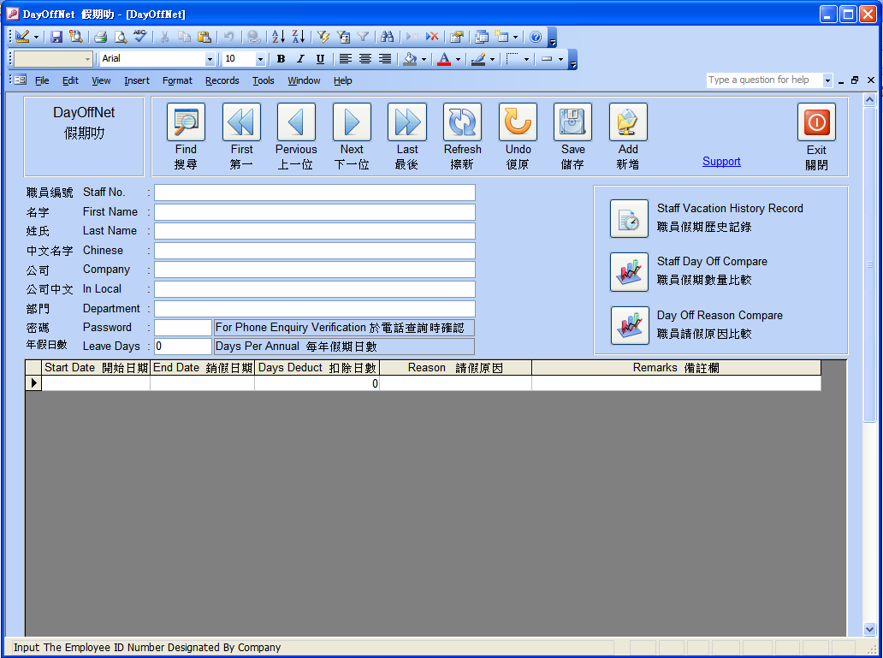

For example a database keeping information for a doctors surgery may contain the following files:
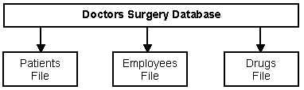
When you set up a database you decide on what files you want to create and what the structure of the records in the files should be. All the records in the same file must have the same structure. The structure of a record refers to the names of the fields that the record contains and the types of these fields. Databases are split up into separate files because:
- Often you want to store information about different kinds of things (e.g. patients, employees) using different record structures. You need to use different files for the different structures.
- Splitting up files can reduce data duplication, saving storage space and improving data consistency.
SPREAD SHEET SOFTWARE
A spreadsheet package is used for performing calculations and drawing charts. When you open a spreadsheet package the screen looks like a very large table similar to this:
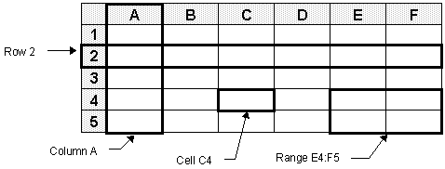
The table is divided into a number of boxes called Cells. You can type information into each cell. Going across the table are many Rows each of which is identified by a number. Going down the table are many Columns each of which is identified by a letter.
Each cell is identified by a unique name called a Cell Reference. The cell reference is formed by writing down the letter of the column that the cell is in followed by the number of the row that it is in.
Groups of joined cells are known as a Range. A range can be described by writing down the cell references of the cells at the top left and bottom right corners of the range with a colon to separate them.
You can enter three different types of information into a cell. The three types are :
- Numbers: Any number.
- Labels: Combinations of letters and numbers used as titles or labels to make the sheet clearer.
- Formulas: Used to carry out calculations with the numbers that are entered into the sheet.
- Formulas : Used to carry out calculations with the numbers that are entered into the sheet.

DESKTOP PUBLICATION
DTP stands for Desktop Publishing. You use DTP software to produce professional-looking documents such as reports, books, posters or leaflets. DTP software gives you more control over the layout of a page than a word processor and lets you easily integrate graphics into your publications.
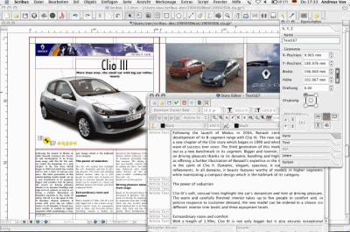

In addition to the features of a word processor you should also expect a desktop publisher to offer you these facilites :
- Page Layout : The ability to define the layout of a page using frames to place text and pictures in.
- Fonts and Styles : A wide range of fonts and styles.
- Drawing Facilities : Some drawing facilities, although these may be limited.
- Importing Pictures and Text : The ability to incorporate pictures and text from other packages into a document.
- Clipart : A library of pictures for you to include in your documents.
- Accurate Positioning : The ability to position objects extremely accurately on the page using guidelines or a grid.
The main features that you can expect to find in a desktop publishing package are described in detail below

GRAPHICS DESIGNING SOFTWARE
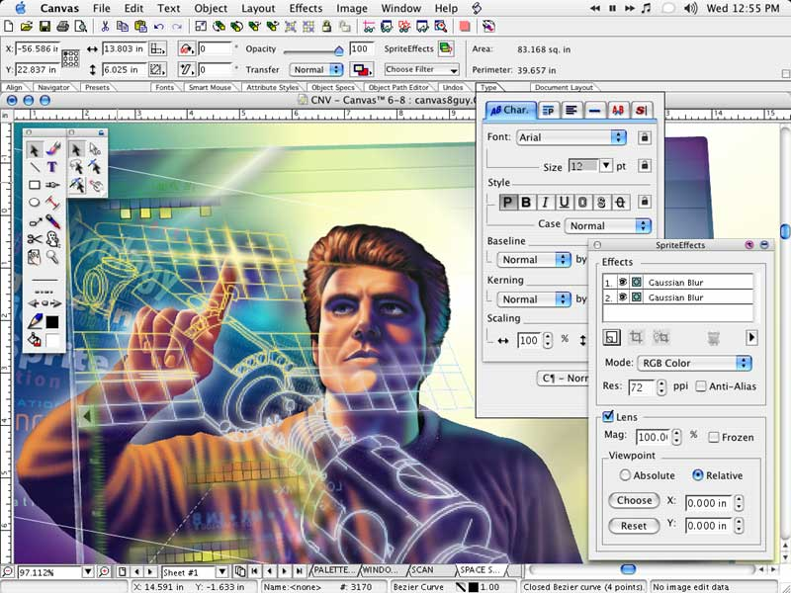
Computer graphics or images are often used either by themselves or to enhance the quality of other documents, for example a desktop published document.

There are three distinct types of package which can be used to create images on a computer. They are :
- Painting Packages: This is the most basic type of graphics package. These packages allow you to paint onto the screen as if it was a canvas. Unfortunately they produce files which take up a lot of storage space and painted images are difficult to edit.
- Drawing / Vector Drawing Packages: These are more sophisticated than painting packages. They store images as a set of objects which can be easily edited.
- Computer Aided Design (CAD) Packages: Very advanced, highly accurate packages which can be used for designing three dimensional objects such as houses and machinery.

